AAUW MO Opportunity Grants Application Form 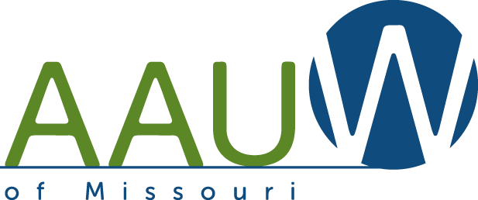
Applications are accepted throughout the year (AAUW year July 1-June 30).
Area applying for (check one):
Peg Witt Grant 1. Branch Enrichment 2. New or Returning Branch
AAUW MO Reserve 3. Attend AAUW Events 4. Project for Program Enrichment
Branch ____________________________________________________________________
Branch Contact Person_________________________________________________________
Address______________________________________________________________________
Email________________________________________________________________________
Phone_______________________________________________________________________
Amount of Money Requested______________________________
Project Description: (Please attach no more than one typed page.) Include a description of your project
(details , goals, and projected outcomes, etc.) and how you will evaluate your project.
Project Budget (list):
Income: Expenses:

The branch understands that, by accepting the money from the state, a representative from the branch will attend the next state conference to tell about your project and have a one-page handout about the project to share with other Missouri branches.
_________________________________ ___________________________
Signature ( typed if sent by e-mail) Date
Applications should be sent to:
Carol Cox, Chair: cjc_51@yahoo.com, 701 Oregon Trail, Boonville, MO 62533-2027, 660-888-8200
Committee member: Carolyn Adams, ceejayaye@yahoo.com

