STEM (Science, Technology, Engineering, and Math) subjects can be a bit heavy for kids, but introducing them through humor and playfulness can make them more accessible and fun to learn. STEM jokes are a great way to get kids interested in these subjects and to help them remember important concepts.

One of the great things about STEM jokes is that they can be used to introduce complex concepts in a simple and engaging way. For example, a joke about atoms making up everything introduces the concept that atoms are the building blocks of all matter, while a joke about a programmer not liking nature because of bugs, brings in the topic of coding bugs and debugging.

STEM jokes can also help break down the stereotype that STEM subjects are only for serious, analytical people. By presenting science, technology, engineering, and math concepts in a playful way, kids are more likely to feel comfortable engaging with these subjects and may even begin to see themselves as future scientists or engineers.

Here are 17 STEM jokes that are sure to make kids laugh and learn at the same time!

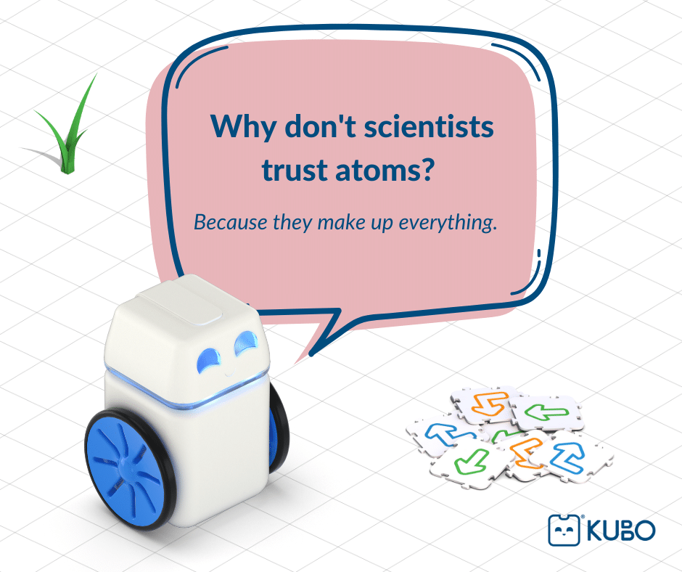

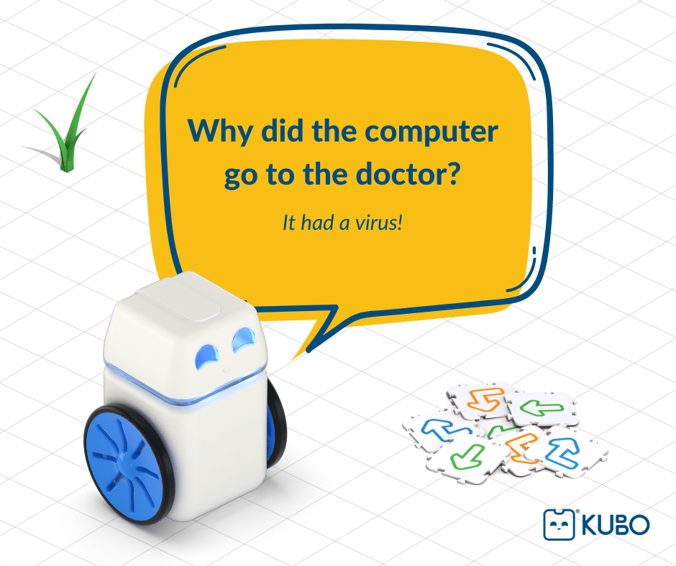

*!*

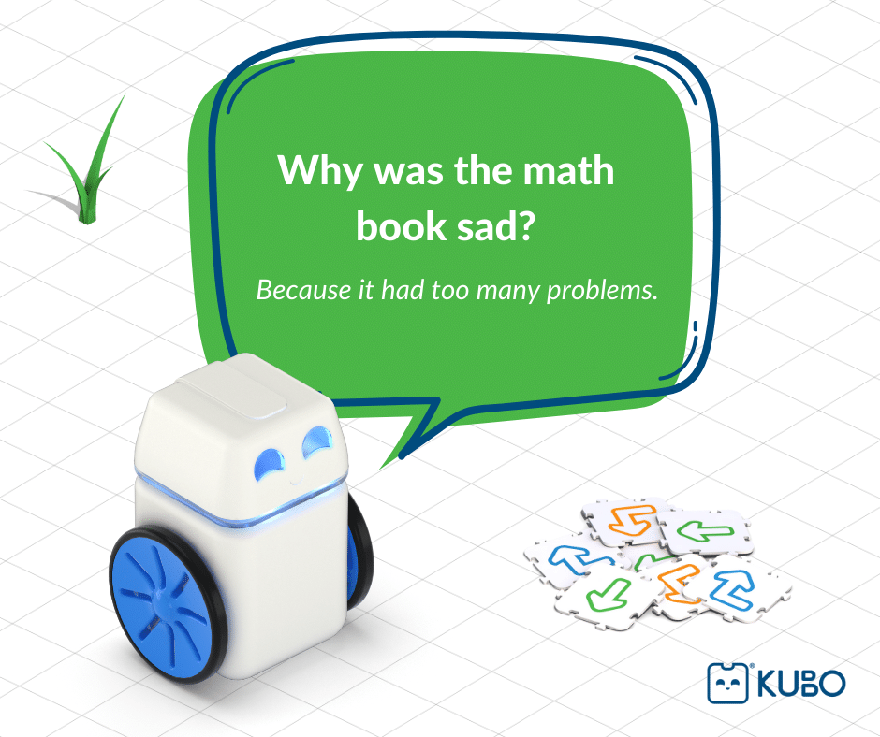

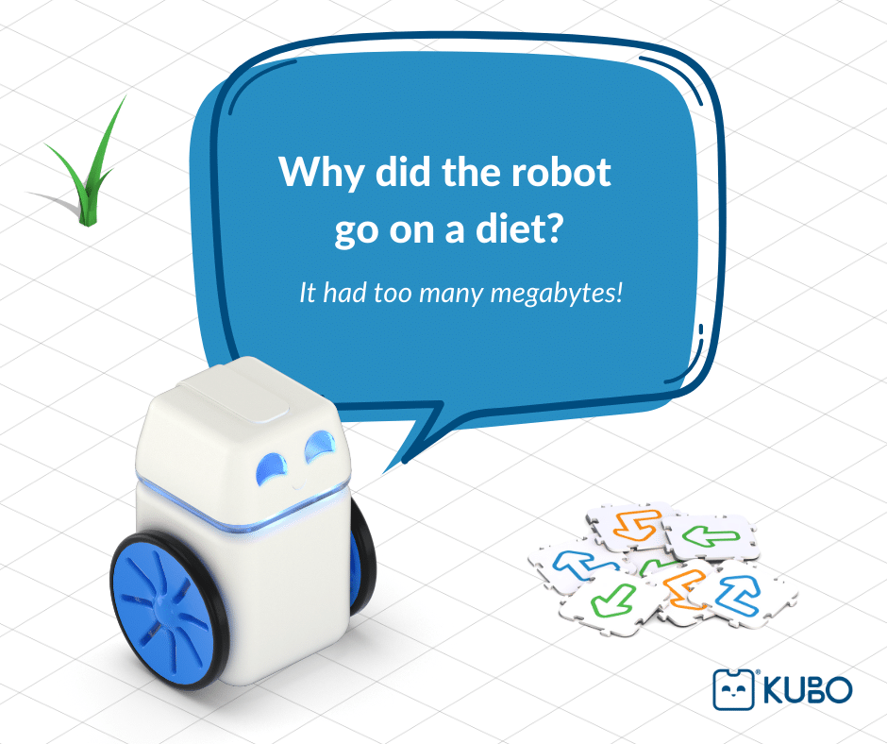

*!*

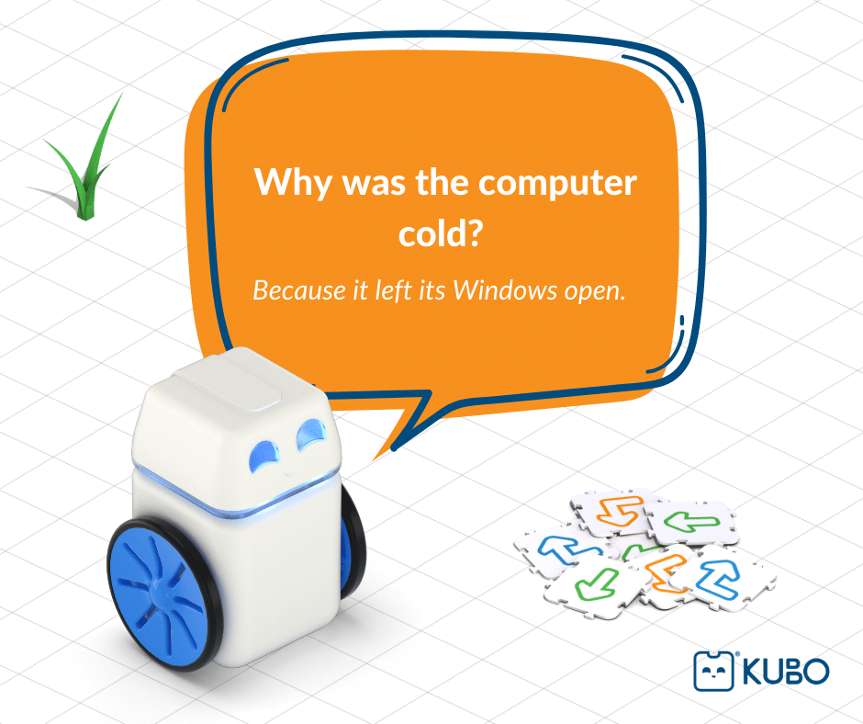

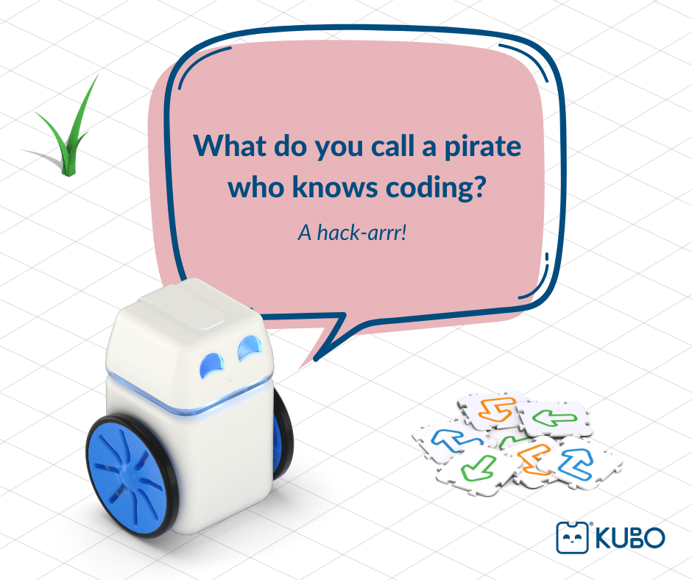

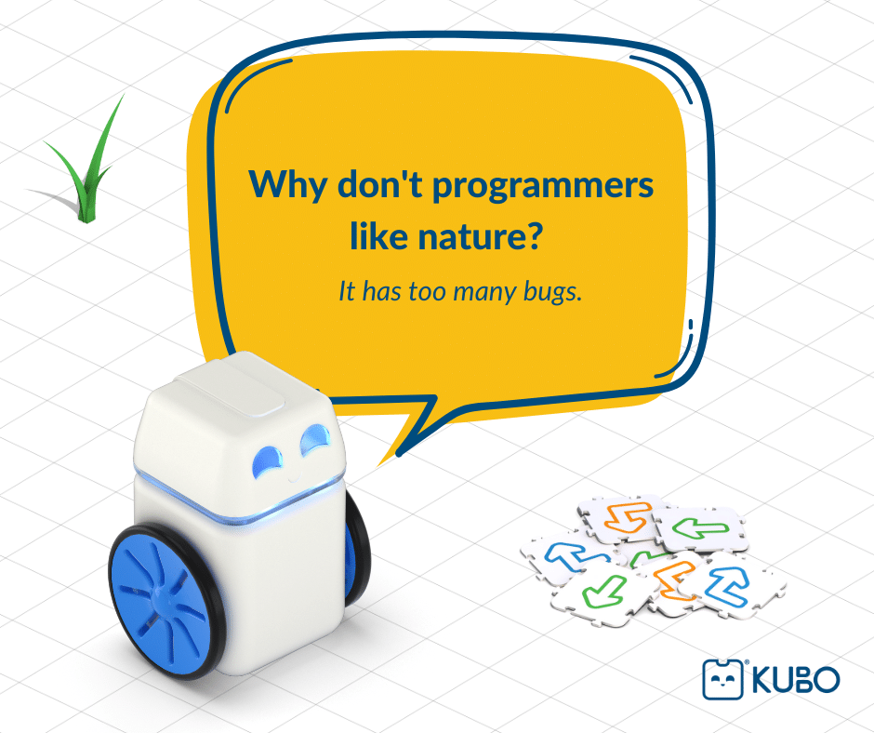

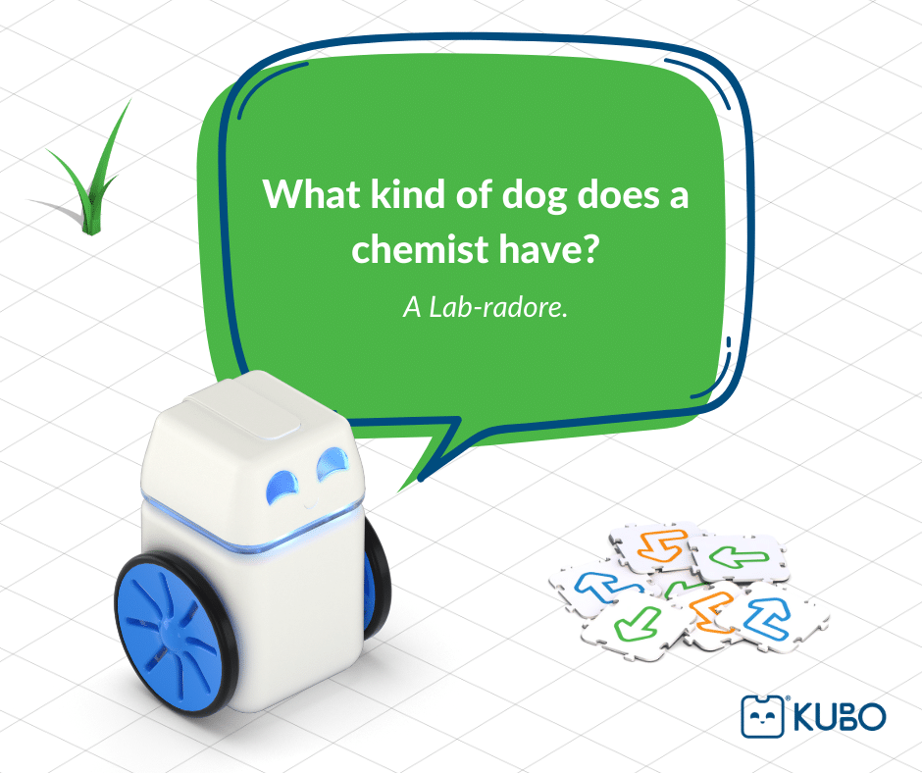

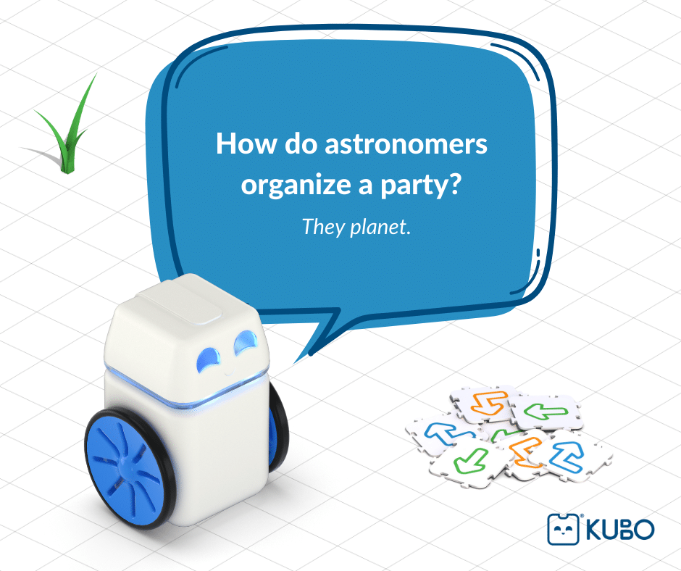

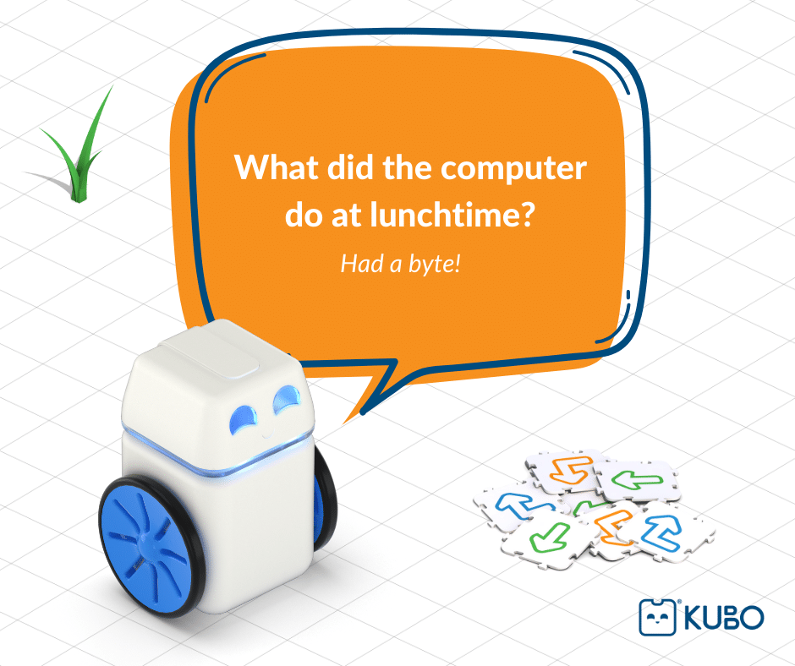

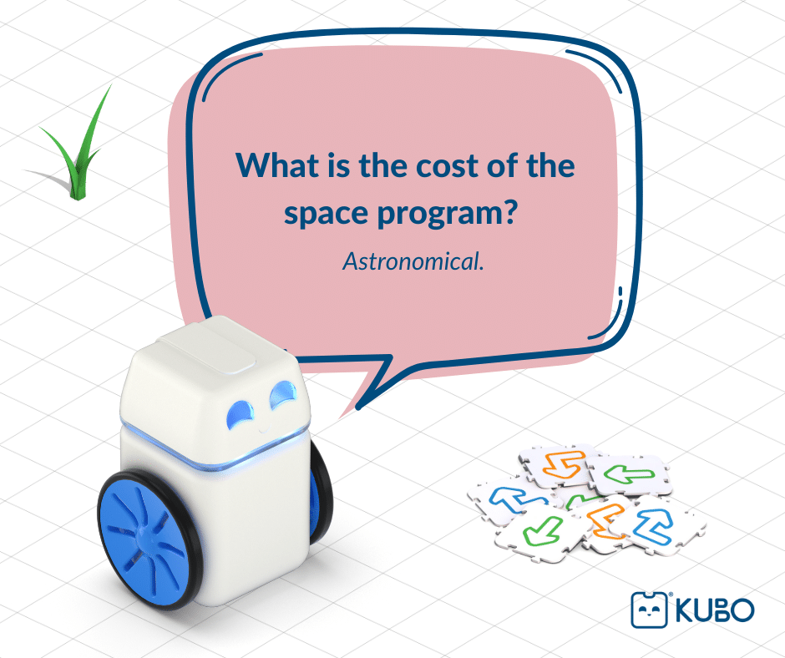

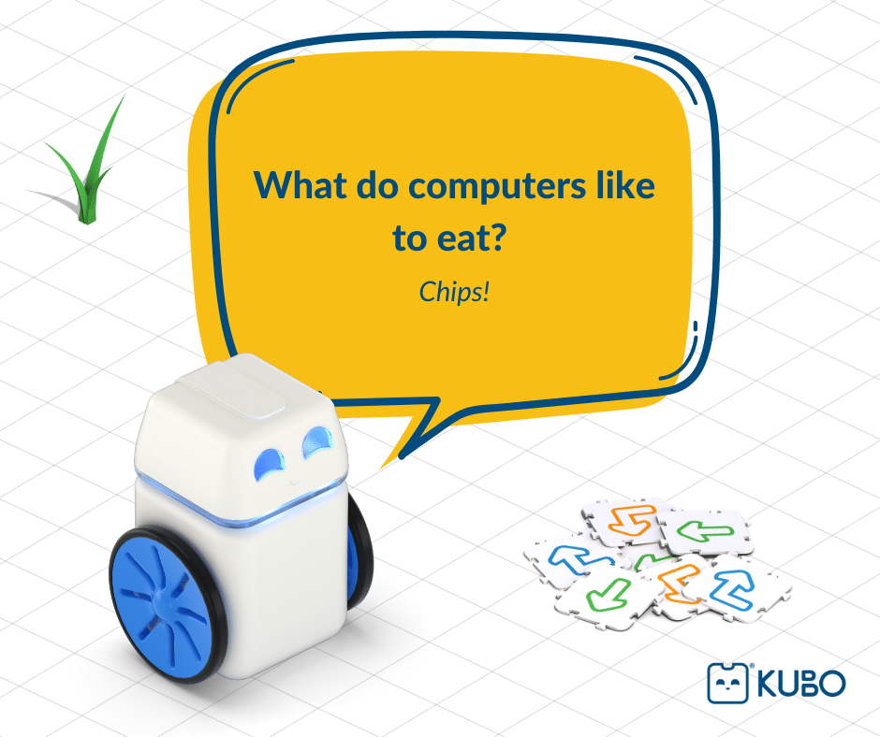

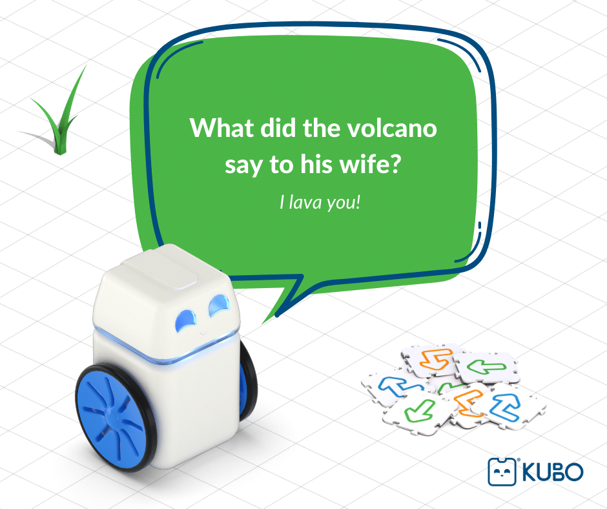

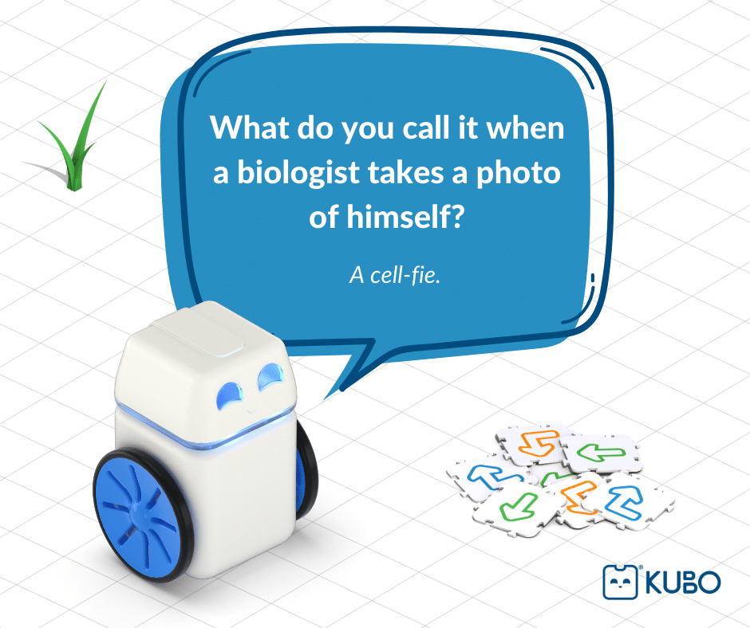

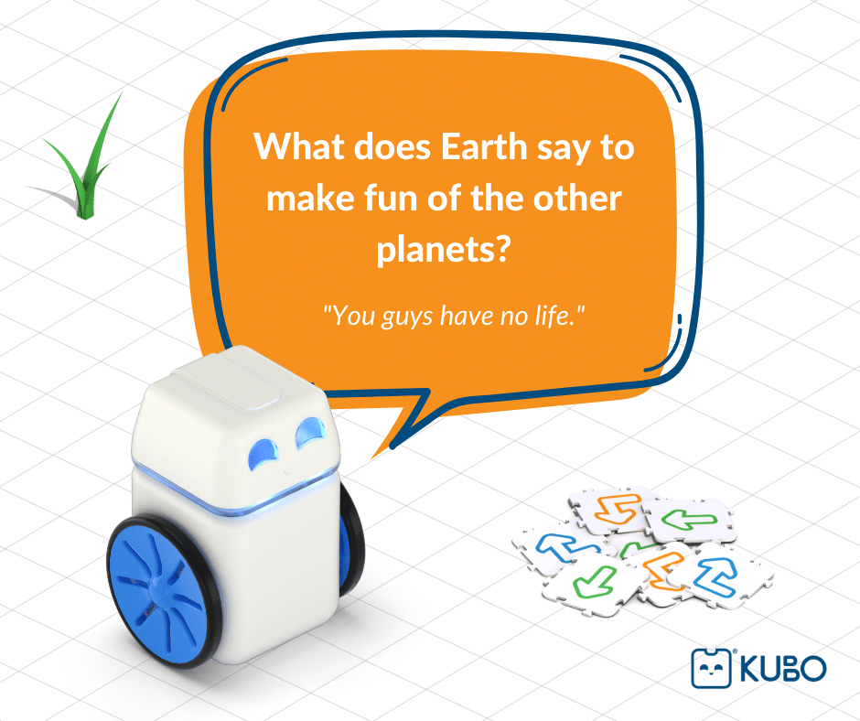

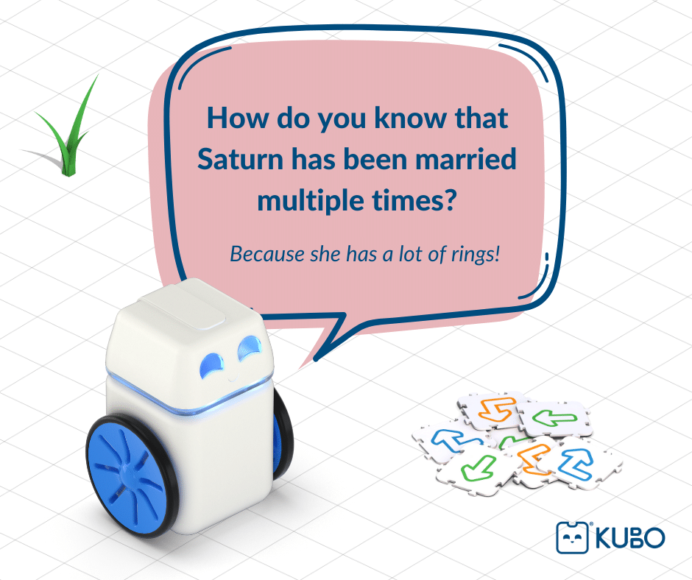

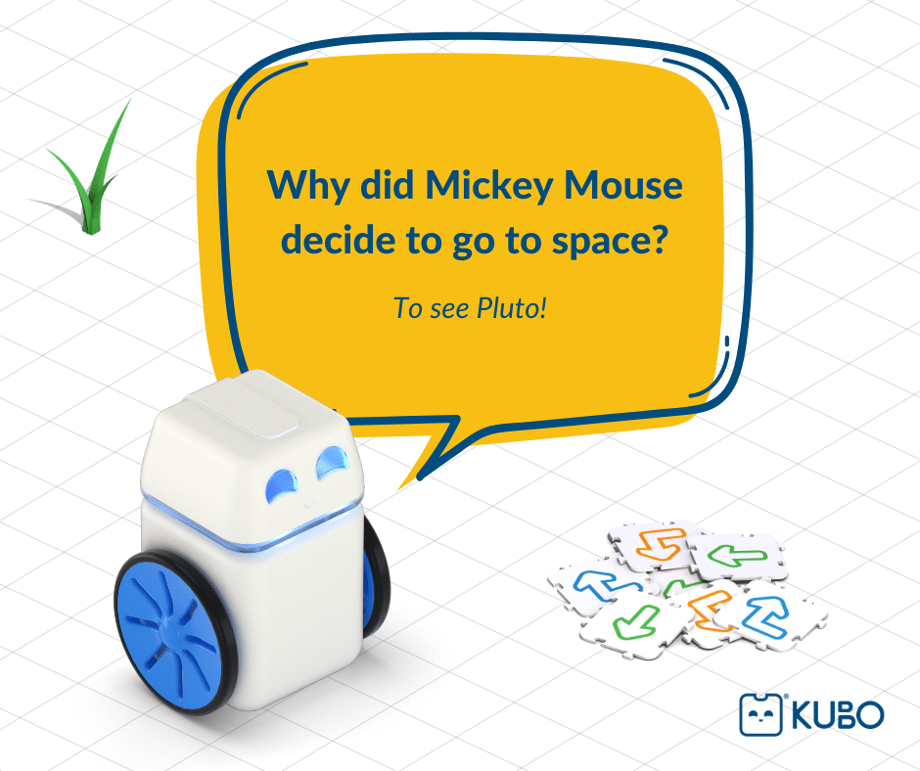

STEM jokes can be a powerful tool for getting kids interested in science, technology, engineering, and math subjects. Whether it’s a joke about the price of a space program or a joke about a biologist taking a photo, these playful jokes can inspire curiosity, creativity, and a love of learning in children.

[[](https://kubo-robot.com/from-code-to-cookies-exploring-the-similarities-between-coding-and-baking/)](https://kubo-robot.com/from-code-to-cookies-exploring-the-similarities-between-coding-and-baking/)

**[Previous PostFrom Code to Cookies: Exploring the Similarities Between Coding and Baking](https://kubo-robot.com/from-code-to-cookies-exploring-the-similarities-between-coding-and-baking/)**