AAUW MO Incentive Grants Application Form 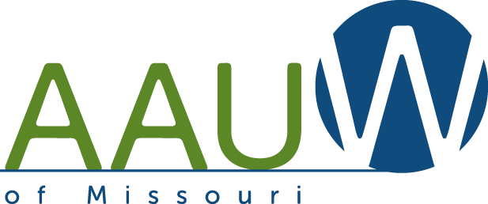
Dates due: Aug. 1st, Nov. 1st, Mar. 1st (calendar year July 1st –June 30th )
Area applying for: check one
Peg Witt Grant 1. Branch Enrichment 2. New or Returning Branch
AAUW MO Reserve 3. Attend AAUW Events (registration only) 4. Project for Program Enrichment
Branch ____________________________________________________________________
Branch Contact Person_________________________________________________________
Address______________________________________________________________________
Email________________________________________________________________________
Phone_______________________________________________________________________
Amount of Money Requested______________________________
Project Description: (Please attach no more than one typed page.) Include a description of your project (details , goals, and projected outcomes, etc.) and how you will evaluate your project.
Project Budget ( list):
Income: Expenses:

The branch understands that, by accepting the money from the state, a representative from the branch will attend the next state conference to tell about your project and have a one-page handout about the project to share with other Missouri branches.
_________________________________ ___________________________
Signature ( typed if sent by e-mail) Date
Applications should be sent to both Co-Chairs :
Pam Kulp , kulpp10@gmail.com ( 1942 Freymuth Court, O’Fallon, MO 63366)
Teri Brecht tebrecht@yahoo.com (805 Longview Drive, St. Charles, MO 63301)

