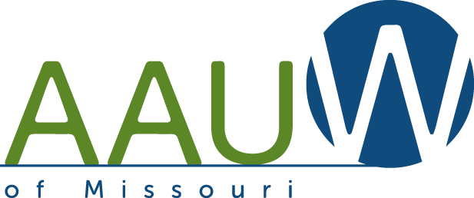
Star Award Application 2019-20
Covering branch activities from April 1, 2019, to March 31, 2020

Use this form to tell us about your branch’s successful year and earn up to 10 MO stars, one for each area of achievement. All successes (large and small, few and many) are important for achieving AAUW’s mission. Place a check in the YES/NO column, and for each YES check provide a brief (50-100 words) explanation of your achievement.
Applications are due April 1, 2020 (postmark or email date).

Branch Name: | Date:
Application completed by: | Position in branch:
Phone Number: | Email:

AAUW MO Goal | YES | NO | JUSTIFICATION
Leadership (Achieve 3 of 6)
- Participated in the AAUW State meeting in Columbia on May 4, 2019.
- Created/updated a strategic plan with goals and target dates for 2019-2020.
- Provided orientation to all branch members on AAUW priorities: Research, Education, and Advocacy.
- Filed 2019-20 branch officer information with National by deadline, July 1, 2019.
- A minimum of 10% of membership voted in the 2019 AAUW National Election (AAUW MO will have participation numbers).
- Served on a state committee.
Programs (Achieve 2 of 3)
- All meetings are handicap accessible.
- Presented AAUW mission-based programs (e.g., Work Smart, education and training, economic security, leadership, governance and sustainability, 2020 Women’s Vote Centennial).
- Had a state or national board member speak at a branch meeting.
Membership (Achieve 1 of 3)  - Maintained or grew branch membership. |  |  | Membership on 2/1/19 _____; on 2/1/20 _____
- Maintained a C/U Partner or supported NCCWSL.
- Gained new members in 2019-20 by participation in the national AAUW Programs such as Shape the Future or Give a Grad a Gift.
Visibility (Achieve 2 of 4)
- Produced a branch newsletter regularly and distributed it to all members.
- Won a Star or Galaxy Award in the previous year.
- Focused on external visibility (branch newsletters will not meet this requirement). Give evidence of publicizing events, programs, & projects (pre-and/or post-event.) All sources must display date and media source. Include newspaper, radio, TV, and social media.
- Participated in a tabling event or similar outreach event.
AAUW MO GOAL | YES | NO | JUSTIFICATION
Educational Equity (Achieve 1 of 3)
- Engaged in a community project(s) related to equity for girls and women (e.g., Deeper in Debt, STEM, Tech Check, Pay Equity, Graduating to the Pay Gap, Bullying).
- Sponsored/supported Operation Equity Book Club (formerly Adelante).
- Recognized girls involved in STEM activities.
AAUW Fund 2019 (Achieve 2 of 4)  - Met the $30 per capita state goal. |  |  | # of members ____X $30 = $________  Branch Total Giving $__________
- Had 1 Century Club Member ($100 or greater individual donation) per 25 branch members in 2019. |  |  | # members ________  # CC members________
- Had 1 Century Club Plus member ($250+ or greater individual donation) per 50 branch members in 2019. |  |  | # members ________  # CC+ members________
- Sponsored an event/activity to benefit the AAUW Fund.
Public Policy (Achieve 2 of 4)
- Completed one gender pay equity activity.
- Completed one Title IX activity.
- Participated in Equity Action Day in Jefferson City.
- Members participated in 2-Minute Activist.
Research and Resources (Achieve 2 of 4)
- Presented information to members about AAUW research.
- Participated in a national AAUW webinar or podcast event.
- Utilized online Tools and References (e.g., Program-in-a-Box, Fundraising, State Policy Sex Trafficking Toolkit, Diversity and Inclusion Toolkit, etc.).
- Sought the expertise and experience of state board members.
Technology (Achieve 2 of 4)
- Transmitted branch newsletters electronically.
- Maintained a branch website.
- Used social networking such as Facebook and email for Branch communication.
- Conducted a participatory event explaining and using Work Smart Online.
Branch Management (Achieve 2 of 3)
- Developed and maintained a balanced branch budget.
- Shared national and state information with branch members.
- Filed branch newsletters, directory/yearbook, and other branch historical documents with AAUW State Historian.

Mail or email completed application to:
Lynne Roney, 412 Oakley Drive, St. Louis, MO 63105
lynneroney@sbcglobal.net, 314-727-7175, c 314-223-3426

DEADLINE: Must be postmarked or submitted by email by April 1, 2020.
You will be notified by email when your application has been received.

